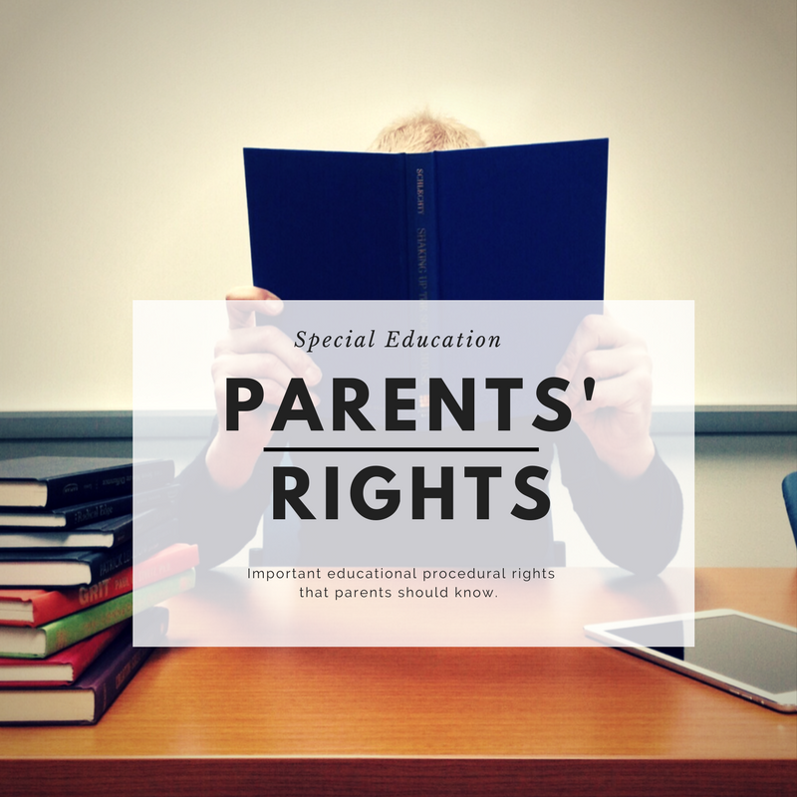

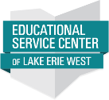
Sponsored By The Parent Mentor Program of Lake Erie West Educational Service Center
and State Support Team Region 1
Empowering Parents with
Students Receiving Special Education
PLEASE JOIN US FOR A
FREE TRAINING!

January 31, 2019
Educational Service Center of Lake Erie West
2275 Collingwood Blvd
Toledo, OH 43620
6:00 pm to 8:00 pm

Presenter:
Jackie Jacoby M. ED
State Support Team Region1
School Improvement & Special
Education
Consultant

REGISTRATION:

Parents of children with disabilities and professionals are invited to
register for this free training by
calling 419-214-3066 or by emailing wsmenner@esclakeeriewest.org

This training will overview the basic concepts of the
Individuals with Disabilities Education Act (IDEA)
pertaining to parents rights.

Participants will gain a
functional knowledge of
parent’s rights under IDEA, special educations laws to
better support and advocate for their child.

